94 94 -> 5 -5 22
94 = Q = {d,db,u,ub,s,sb,c,cb,b,bb}
5 = b
22 = P

Process
We considered the production of a photon and bƀ pair to determine whether the interference of the process via Z⁰ and other methods is significant. We used the Sherpa Monte Carlo event generator to generate the following events:
- 40000 events with the QQ →Z(→ bb) + γ process; this is the isolated signal (s)
- 40000 events of Q Q→ bb + γ where Q is any [light] quark [parton], not via Z; this is the isolated background (b)
- 60000 events of Q Q→ bb + γ via all processes (using photons, gluons, and Z) for the combined and interfered signal + background (sb)
These event processes were generated by changing the Order parameter: s used order (*,3), b used (*,1), and sb used (*,*). The first term in the brackets refers to the order of QCD couplings, and the second to the order of electroweak couplings.
The selectors used to select events were:
- the mass of each b is greater than 66 GeV
- the transverse momentum (PT) of the photon is greater than 200
The generator used a beam of energy √s = 13 TeV and further particle decays were switched off.
The events produced were [analysed?] by Delphes.
The respective cross-sections are: s = 0.02205 pb ± 1.42%, b = 0.1194 pb ± 0.71%, sb = 0.1439 pb ± 1.92%.
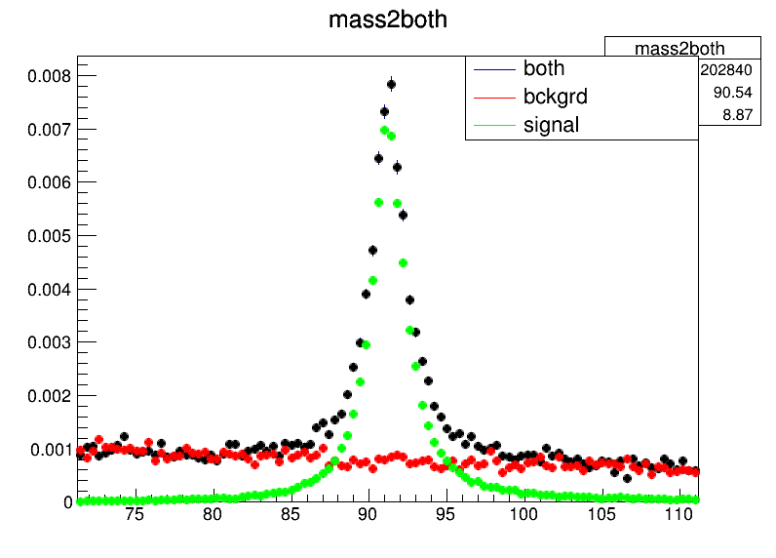
Having collected the data, we plotted a histogram of the combined mass of the bb pair against number of events; this is shown below around mass = ~91 GeV, the mass of Z which is expected. The background data follow a rather straight exponential but the signal has a large peak at m = 91 GeV, as expected for a bb pair formed from a Z. The combined plot looks to be a simple addition of the two, which it would be if there is no interference. To better see the interference, we subtract from the combined plot the background plot and compare the result with the signal; they would be identical if there is no interference. This plot is shown below, with the difference between them plotted in blue.
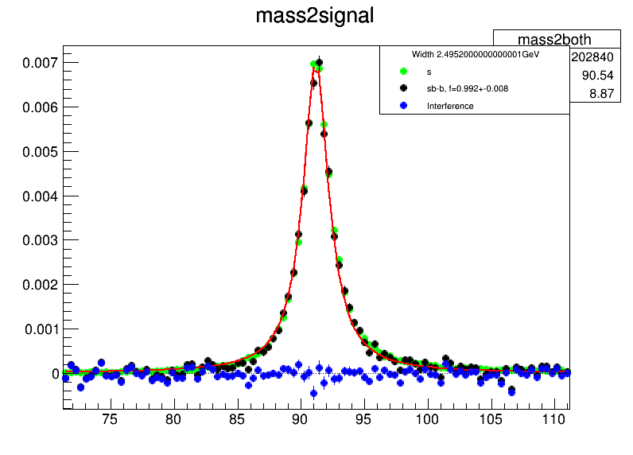
The fit line had width fixed at 2.4952 GeV, the literature value for the width of Z, and the mass was fitted; it was found to be 91.267 GeV with an error of 5.4137 MeV.
It can be seen that the interference (difference between the two plots) is negligible; the variations are statistical fluctuations.

